
Research Ethics for All:
Accessible Research Ethics Education for Community Research Partners

IRB Approval Information

About Research Ethics for All

Overview
Research Ethics for All provides community research partners with developmental disabilities accessible education in ethical issues in patient-centered research, including patient-centered comparative clinical effectiveness research and the responsible conduct of research. This education is focused on the roles and responsibilities of community research partners.
Community research partners can complete this training and earn certification for research ethics education. Research Ethics for All prepares community research partners for responsibilities related to The Common Rule--the US policy for protecting research participants. Research Ethics for All also helps community researchers understand their rights and responsibilities related to the Responsible Conduct of Research.
Research Ethics for All prepares community research partners for responsibilities related to:
- Finding people to be in research studies (recruitment)
- Working with children and adults to make decisions about being in research studies (consent and assent)
- Collecting information from people, conducting clinical trials, conducting patient-centered comparative clinical effectiveness research, working with information that can tell us who a person is (data collection, individually identifiable data)
- Understanding risks and safeguards
- Writing about how research was done and research findings (authorship and dissemination)
Research Ethics for All uses ideas from the Disability Rights Movement to inform research ethics. These ideas include showing respect to people by assuming they can do things and facilitating their responsible inclusion in research. These ideas from the Disability Rights Movement can identify approaches to research and inclusion of people with disabilities in research that balance rights to self-determination and safety.
This website also provides resources for pursuing Institutional Review Board (IRB) approval of Research Ethics for All as an acceptable research ethics training program leading to certification. Click here to see universities that have approved Research Ethics for All.
Research Ethics for All is also available via the CITI Program to subscribers of the Human Subjects Research (HSR) series subscribers.

Learning Outcomes
Research Ethics for All supports community research partners to learn about ethical practices and decision-making in patient-centered research, including patient-centered comparative clinical effectiveness research. Completion of the training provides certification in research ethics and compliance for topics relevant to community research partners engaged in patient-centered research.
Research Ethics for All supports community research partners to achieve the following learning outcomes:
- Define research with people, jobs of different people on a research team, and ways community research partners can make research more ethical and respectful.
- Describe rules related to research with people (Belmont principles, The Common Rule, HIPAA, FERPA, FDA, GINA)
- State why there are rules for research with people and rights of research participants.
- Describe how to use IRB-approved recruitment and consent materials, follow eligibility criteria, and work with children and adults with and without guardians to make informed, voluntary, and ongoing decisions about being in a research study.
- Discuss how to keep research participants safe, including in clinical trials and patient-centered comparative clinical effectiveness research, and what to do when there is information that cannot stay confidential.
- Explain responsibilities of community research partners, including ways to protect the rights and well-being of people who are in research and community research partners, one’s own team's rules, conflicts of interest, and authorship.
When Research Ethics for All training is delivered by a project leader, learners earn certification by completing the certification activities.
See the end of this document for how Research Ethics for All compares to CITI Social-Behavioral-Educational and Biomedical courses.
Training Audience
Research Ethics for All is for community research partners without advanced scientific degrees who will interact with research participants and/or their individually identifiable research information. Research Ethics for All can also be used for community research partners who want to learn about research ethics but don’t need training certification.
Training Development
Research Ethics for All was created by people with developmental disabilities, disability service providers, researchers, and human research protections experts.
We developed Research Ethics for All by deciding together what community research partners with developmental disabilities need to know. We reviewed other research ethics training programs, identified ethical issues related to doing patient-centered comparative clinical effectiveness research with people with developmental disabilities, and shared our experience and expertise. We worked together to make Research Ethics for All disability accessible.

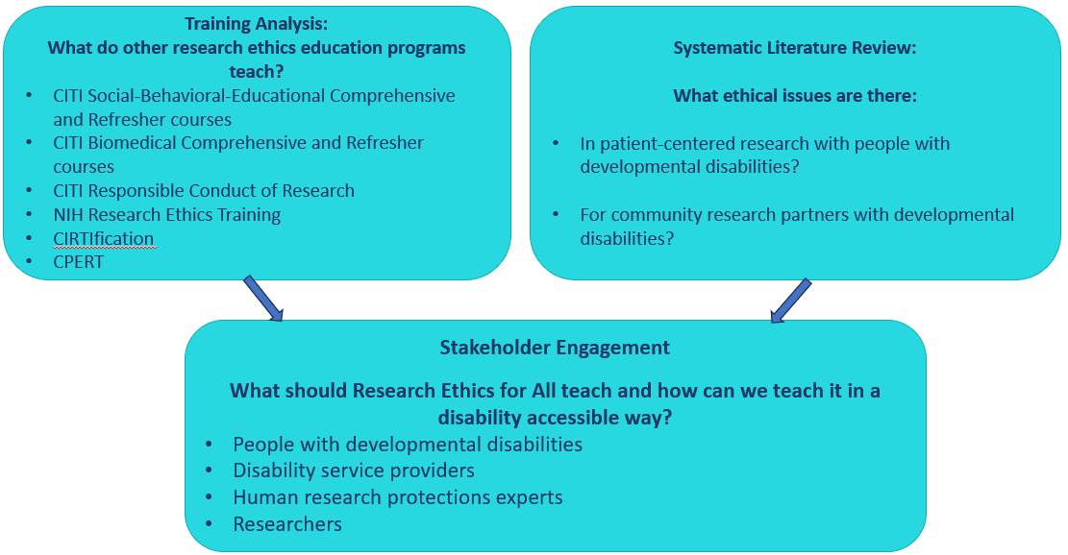

Funding

Research Ethics for All was funded through Patient- Centered Outcomes Research Institute® (PCORI®) Eugene Washington PCORI Engagement Awards (EASC-IDD-00301 and EACB-38863; Co-Leads McDonald and Schwartz). The statements presented in this work are solely the responsibility of the author(s) and do not necessarily represent the views of the Patient-Centered Outcomes Research Institute® (PCORI®).

Training Comparison

Content | CITI Social-Behavioral-Educational and Biomedical | Research Ethics for All
History and Ethics
Introduction to scientific research, including societal benefits
Human Subjects Research
Defining research ethics
Federal Laws and Regulations: The Common Rule

Institutional Review Board (IRBs)
Risks in social-behavioral-educational research
Risks in behavioral and biomedical clinical research (including genetic research)
Safeguards: Preventing and mitigating risks
Certificates of Confidentiality
Consent: Informed, Voluntary, Ongoing
Consent capacity
Assent and Legally Authorized Representatives (LARs)
Privacy and Confidentiality
Research with prisoners
Research with children
Research in schools
International research
Internet-based research
Unanticipated problems and adverse events
Data Safety Monitoring Boards and Committees (DSMBs/DSMCs)
Mandatory reporting
Research with workers/employees
Research with individuals with questionable consent capacity
Vulnerability in research

Conflicts of interest (including financial)
Records-based research: HIPAA and FERPA
Data sharing
Return of personal health results
Belmont Principles
Research with pregnant people, fetuses and neonates
Group harms
FDA Regulations
Eligibility
Recruitment
Using IRB approved research materials
Deception
Using AI in research
Authorship
Safety of community research partners

Citation: McDonald, K. & Schwartz, A. (2026). Research Ethics for All: Accessible Research Ethics Education for Community Research Partners. Syracuse University, Institute on Disability: University of New Hampshire. [www.re4all.org]

©2026, Syracuse University, Institute on Disability: University of New Hampshire. All rights reserved. www.re4all.org

